**Assignment II**

**Analysis on the square - root transformed Strength (Dependent var) to test for differences between Brands, Water levels, and interactions**

Three-way ANOVA simultaneously test three hypotheses:

1. H01: µ Decorator = µ Comfort

Ha1: µ Decorator ≠ µ Comfort

2. H0 2: µ of 0 waterdrop = µ of 5 waterdrops = µ of 15 waterdrops

Ha 2: Not all mean strengths of water level are same.

3. H03: there is no interaction between Brand and Water.

Ha3: there is an interaction between Brand and Water.

anova2 <- aov (sqrt (Strength) ~ Brand + fa.water + Brand * fa.water, data = papertowels)

summary(anova2)

**Brand**

Test statistic – F value = 448.5

p-value = 0.00000000000000019 < 0.05

Decision: Reject Ho (p-val < 0.05)

Conclusion: There is significant evidence to conclude that mue of Decorator differ from mue of Comfort at 5% significance level.

**Water**

Test statistic – F value = 2449.8

p-value = 0.00000000000000019 < 0.05

Decision: Reject Ho (p-val < 0.05)

Conclusion: There is significant evidence to conclude that at least one mean strength of water added to the centre of paper towel differs at 5% significance level.

**Brand * Water**

Test statistic – F value = 163

p-value = 0.00000000000000019 < 0.05

Decision: Reject Ho (p-val < 0.05)

Conclusion: There is significant evidence to conclude that an interaction exists between brand and water at 5% significance level.

**Let’s check the main effects plot to examine whether differences exists between means of different factor levels as stated by hypothesis test.**

**Main Effects plots**

The main effect plots are the graphs plotting the response means for each value of a categorical variable. Since, the line is not horizontal***, main effect exists for brand***. ie the square root of strength (response mean) is not same across all factor levels (comfort & decorator) of brand. The slope determines the magnitude of main effect.

Since, the line is not horizontal***, main effect exists for different levels of water***. ie the square root of strength (response mean) is not same across different drops of water.

**Interaction Plot**

Since, the lines are not parallel, a possible interaction exists between ***brand and water***.

x.factor = Brand, trace. factor = fa. water

x.factor = fa. water, trace.factor = Brand,

**Checking Assumptions for Anova**

( i ) The observations within each factor-level combination are independent and identically distributed.

(ii) Each factor-level combination has equal variance.

- max (sij) = min (sij) < 2

- Levene's test of homogeneity of variance

(iii) The residual values follow a normal distribution with a mean of zero.

**Assumption Check**

1. **Equal variance assumption.**

max (sij) / min (sij) < 2

sd.max / sd.min = 1.64

1.64 < 2, which means each factor level combinations have **equal variance.**

1. **Levene's test of homogeneity of variance**

**Ho: All factors are equal (All variances are equal)**

**Ha: At least one factor is different (Not all variances are equal)**

**P-value = 0.03536 < 0.05**

**Decision: Reject H0**

**Conclusion: We have sufficient evidence to conclude that at 5% significance level, variances are not equal for all factor levels.**

Here, we consider the result from both max /min and residual plot to indicate equal variance instead of Levene’s test and conclude that variances are equal.

1. **Residuals Vs fitted Plot - check the homogeneity of variances**

The red lines representing the mean of the residuals are all basically horizontal and centred around zero. Samples are randomly spread across the mean which means each factor level combinations have **equal variance.**

1. **Histogram of the residuals - Normality check**

The histogram is **fairly symmetric and mound shaped**, which **describes normal distribution.**

1. **Normality Plot of the Residuals (Q-Q plot)**

The residuals follow an approximately straight line in the **normal probability plot, so we can assume normality.(Q-Q gives the best normality check)**

**Tukey HSD Anova**

test of brand – no need of tuskey

3 different categories for water- to find which one is different - use tuskey

If no significant interaction between variables - no tuskey

Tukey HSD performs multiple pairwise comparison, to determine if the mean difference between specific pairs of groups is statistically significant.

____________________________________________________________________________

The p adj value tells if there is a significant difference between comparisons.

To know if there is a statistical difference, **first and foremost you have to check when you ran your anova test. If the p-value is greater than 0.05, then there is no need to run post hoc tests such as the Tukey because you already know that there is no significant differences.** I am sure that in this example, the p-value was greater than 0.05 for the anova test, which is why when you ran the post hoc Tukey test, no significant differences was observed.

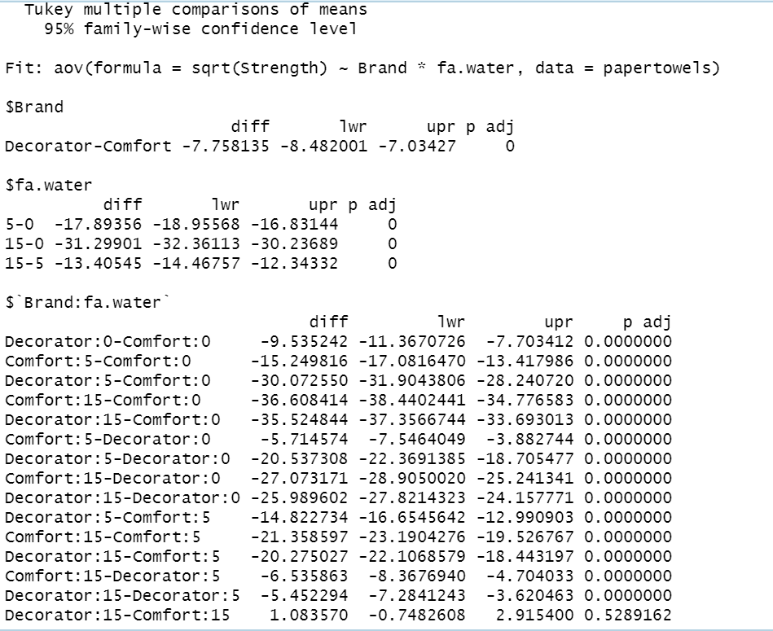

The effect of number of water drops are statistically significant (p-value = 0) 0 < 0.05

The effect of brand is statistically significant (p-value=0) 0 < 0.05

The effect of brand on the square root of strength appears to be significantly dependent by the number of water drops,

So Brand does have an effect through its interaction with the number of water drops with an exception of pair Decorator:15-Comfort:15

**Any confidence intervals that do not contain 0 gives evidence of a difference in the groups**.

